**NFCSD Art Educators May 25, 2020**



**Kindergarten & First-Grade Art Project**

Supplies: Paper and any of these: pencils, crayons, colored pencils, markers, pen or paint made for young artists.

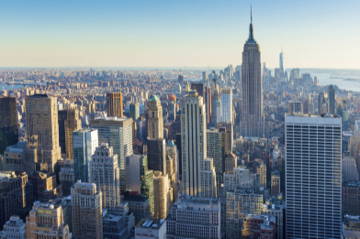 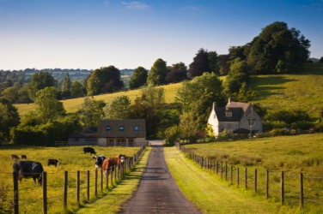

**City Space, Country Space**

These two pictures are photographs (photos) of real places. Photographs are pictures made with a camera. The photo on the left is a view of Manhattan Island in New York City. The photograph on the right is a countryside landscape.

**\*Brainstorm!** **Have you ever seen places like these?**

What things do you see outdoors in the city? What do you see in the country?

**\*Look carefully at the shapes you see in these pictures.** Which shapes have been made by people? Which shapes are free form, made by nature?

**\*Space is the empty area around and between shapes**. Point to the empty areas where you can see space in each picture. How is city space different from country space? Does the sky surround some shapes in both pictures?

\***Draw a picture of a city or a countryside and share it with someone.**

Imagine what it would be like to live there. What kind of things could you?